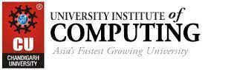

DESKTOP PUBLISHING PROJECT REPORT

NAME- RAVI

UID- 23BCA10285

SECTION- 4-A

SUBMITTED TO- Ms Shivani Chadha

PROJECT TITLE- DESIGNED A POSTER USING PHOROSHOP

**CONTENTS: -**

1. INTRODUCTION…………………………………………………

The goal of this project is to develop creative skills in designing poster that cater to various contexts, keeping in mind the principles of visual hierarchy, color theory, typography, and user engagement. Through this project, participants will learn to use design tools, explore layout strategies, and understand the significance of branding in poster creation.

1. OBJECTIVE OF PROJECT……………………………………..

The objective of this project is to design visually appealing and effective poster that communicate messages clearly, align with branding goals, and engage the target audience across various digital and print platforms.

1. PROCEDURE OF DESIGNING……………………………..

Followed the right steps for creating poster using Adobe photoshop.

1. PROJECT OUTPUT IMAGES…………………………………

Pasted the results of poster designing.

1. CONCLUSION………………………………………………….

This project highlights the importance of well-designed poster in communication and branding. By applying design principles, creative tools, and layout techniques, participants gain valuable skills to create effective poster that capture attention and deliver messages clearly across different platforms.

**Poster Design Using Adobe Photoshop**

**Introduction:**

Poster design is a creative process that involves combining text, imagery, and graphic elements to communicate messages effectively. It serves various purposes, such as promoting events, advertising products, or spreading awareness. Adobe Photoshop is a powerful tool that allows designers to bring their ideas to life, offering a wide range of features for photo editing, typography, and layout creation.

**Objective:**

The objective of this project is to design a visually appealing poster using Adobe Photoshop that effectively communicates a specific message, captures attention, and aligns with the intended theme or purpose.

1. Learning essential poster design principles.
2. Mastering Photoshop tools like layers, text, and effects.
3. Designing a poster with specific dimensions and resolution.
4. Applying creativity and branding consistency.
5. Exporting the poster in formats suitable for web or print.

**Steps to Create a Poster Using Adobe Photoshop:**

1. **Setting Up the Canvas:**
   1. Open Adobe Photoshop and create a new document.
   2. Set dimensions according to your poster needs (e.g., A3: 297mm x 420mm or Custom: 1080px x 1920px for digital).
   3. Choose an appropriate resolution (300 DPI for print, 72 DPI for web).
2. **Background Design:**
   1. Select a background color or use an image.
   2. Apply gradients, textures, or patterns to create depth.
3. **Adding Text and Typography:**
   1. Use the **Text Tool (T)** to add titles, subtitles, or slogans.
   2. Experiment with different fonts and text styles (bold, italic, etc.).
   3. Adjust spacing, alignment, and size to enhance readability and visual hierarchy.
4. **Inserting Images and Graphics:**
   1. Import relevant images using **File > Place Embedded**.
   2. Use the **Pen Tool (P)** or **Shape Tool** to add graphic elements such as icons or shapes.
5. **Enhancing the Design with Effects:**
   1. Apply **Layer Styles** (Drop Shadow, Stroke, etc.) for visual impact.
   2. Use blending modes to create artistic overlays or adjust opacity for subtle effects.
6. **Organizing Layers:**
   1. Group related elements and name layers to keep the project organized.
   2. Lock layers that you won’t modify to avoid accidental changes.
7. **Final Adjustments:**
   1. Check alignment, colors, and spacing for a balanced look.
   2. Use **Adjustment Layers** (Brightness/Contrast, Hue/Saturation) to fine-tune the poster’s overall appearance.

8. EXPORTING THE poster:-

Web Export (JPEG, PNG): Go to File > Export > Save for Web (Legacy) and select JPEG for standard images or PNG if the banner has transparency. Optimize file size without losing quality.

Print Export (PDF): For print poster, go to File > Save As and choose PDF with high resolution (300 DPI) settings.

File Naming: Ensure you save the banner with a meaningful name and correct file format depending on its use.

10. REVIEW AND FEEDBACK: -

Review the final poster for any design or content errors.

Share the design with stakeholders or team members for feedback and make necessary revisions.

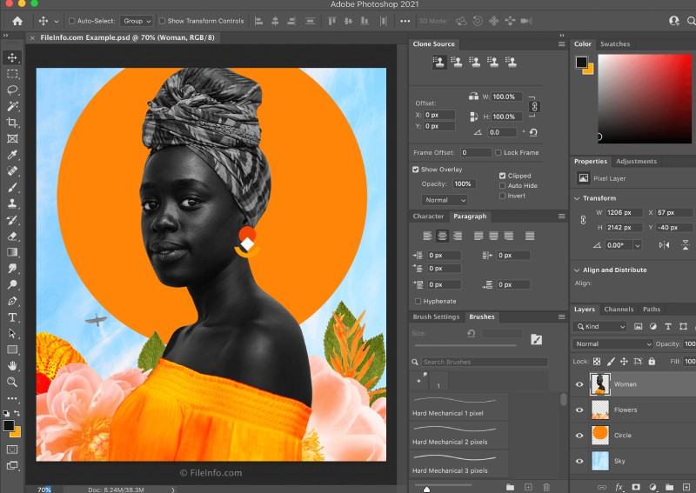OUTPUT IMAGE: -

**Conclusion:**  
Designing a poster using Adobe Photoshop is a comprehensive process that combines creativity with technical skills. Through this project, users learn how to effectively use tools like typography, imagery, and graphic elements to convey messages in a visually engaging way. The steps covered—ranging from setting up the canvas to applying effects and exporting—ensure a polished final product suitable for both digital and print platforms. This project not only enhances proficiency in Photoshop but also provides valuable insights into design principles, helping participants create professional posters that align with the desired theme and purpose.